**L 2 : Installing Git and Initial Setup for Git :**

* Go to <https://www.git-schm> (official website of git), in this side you find the setup for git in win, mac, linux.
* Now download git for windows version.
* **Note :** Current version of git : **Date :**
* Now, installing is easy just do next and next.
* Git software, consist two things git command line tool or interface (git GUi) and git bash.
* Git Bash is a terminal for git.
* Windows powershell is a window based terminal, used in windows.
* You can use git through cmd, powershell and git bash.
* Check git install or not ??
* $ git command hit
* Why they give git bash kuki aap linux mac or other os per bhi jaye toh wahan bhi same cheeje chala sakein.

Git bash

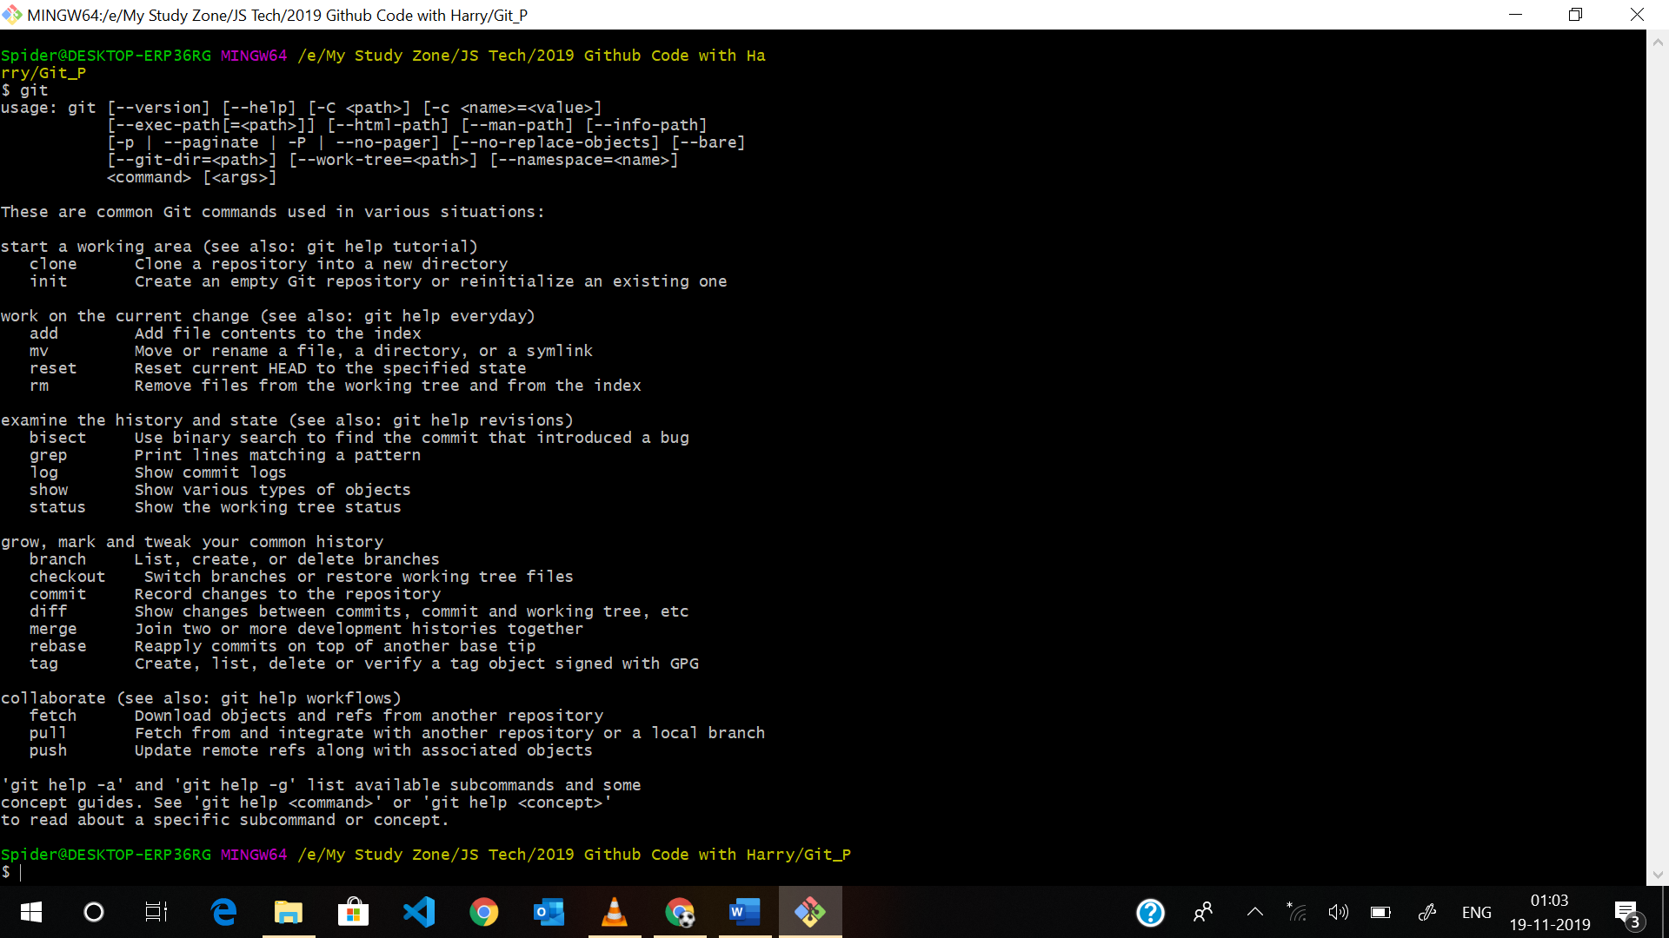

Windows powershell:

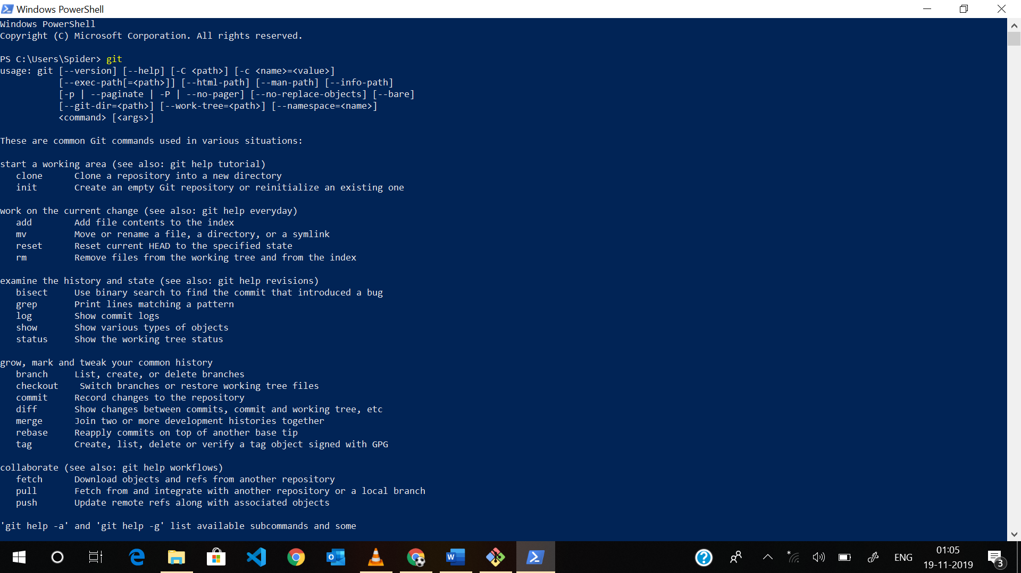

Git GUI :

Many gui available in market to pull push commit check status etc through UI example tortoise git, visual studio code , Note but it consist less feature as compared to command line tools, these GUI internally used git bash commands

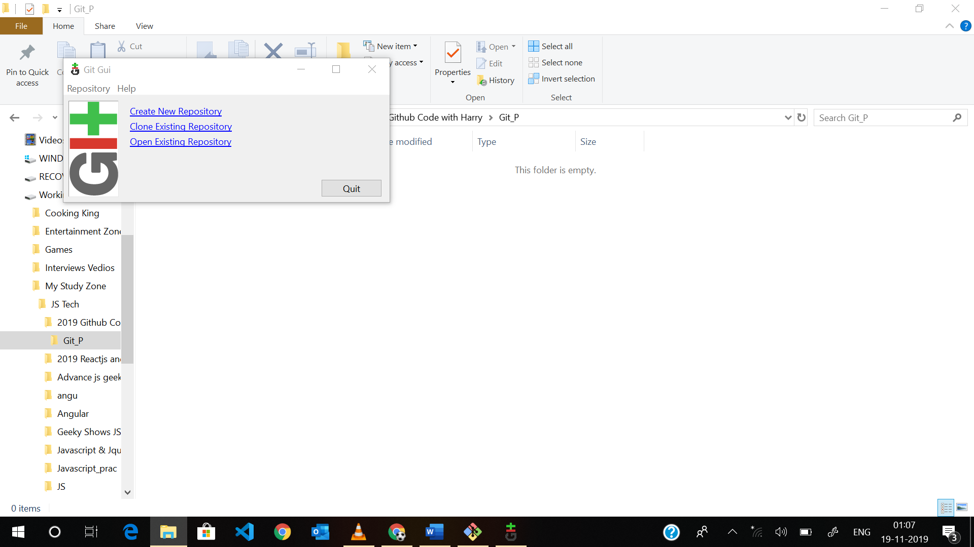

Commands in windows :

Cd change directory : from c to d to e : like cd fullpath

Pwd : present working directory

Shortcut to open git bash : shift + right click

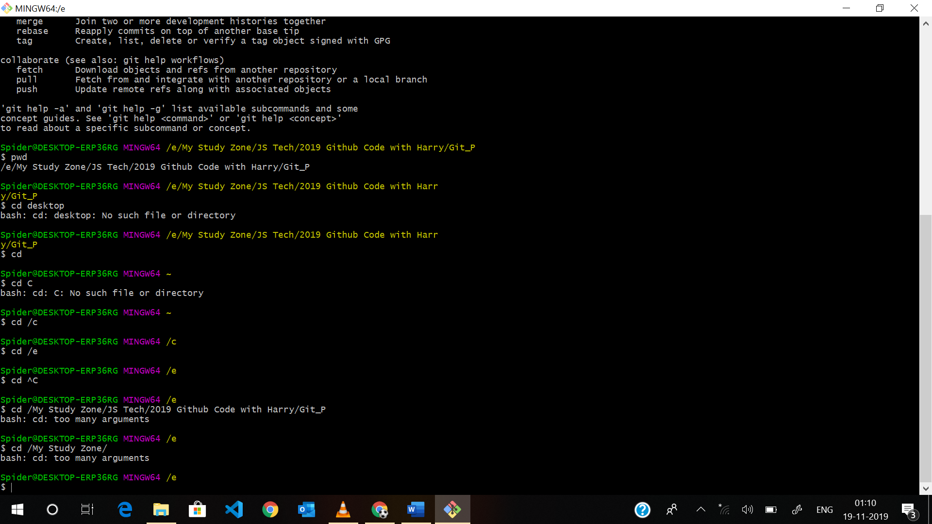

**Setup git :**

Setup ur username password (git ko bta de hum kon hai), so that when our you commit (take snapshot), toh git ko pta chale kisne commit kiya hai kab kiya hai or kya commit kiya hai

$ git config --global user.name "Satty Thakur"

This will configure the username or set in git

$ git config --global user.email "satyendrasinghjob@gmail.com"

Spider@DESKTOP-ERP36RG MINGW64 /e/My Study Zone/JS Tech/2019 Github Code with Ha

rry/Git_P

$ git config --list

core.symlinks=true

core.autocrlf=true

core.fscache=true

color.diff=auto

color.status=auto

color.branch=auto

color.interactive=true

help.format=html

rebase.autosquash=true

http.sslcainfo=C:/Program Files/Git/mingw64/ssl/certs/ca-bundle.crt

http.sslbackend=openssl

diff.astextplain.textconv=astextplain

filter.lfs.clean=git-lfs clean -- %f

filter.lfs.smudge=git-lfs smudge -- %f

filter.lfs.process=git-lfs filter-process

filter.lfs.required=true

credential.helper=manager

user.name=Satty Thakur

user.email=satyendrasinghjob@gmail.com

Note : You can also set ur editor but only useful in linux , no need in windows

git config --core.editor vim

how to check name:

Spider@DESKTOP-ERP36RG MINGW64 /e/My Study Zone/JS Tech/2019 Github Code with Ha

rry/Git_P

$ git config user.name

Satty Thakur

Spider@DESKTOP-ERP36RG MINGW64 /e/My Study Zone/JS Tech/2019 Github Code with Ha

rry/Git_P

$ git config user.email

satyendrasinghjob@gmail.com

Note : hum inko change bhi kar skte hai in username or email ko.

**L 3 : Three stage architecture:**

Working directory : windows explorer 1st stage.

Staging area : jo file next stage per jaye hi jaye , ruke na , 2nd stage , 1o katte mein se 1 kilo atta nikal liya or stage krdiya then truck mein load krdiya.

.git : git ki yeh hidden file rahegi, or yeh sari files ka snaphot, or compressed or sari files ki information rakehga.

Note /: hum directly bhi load kr skte hai bina staging area mein dale, bu not gud way.

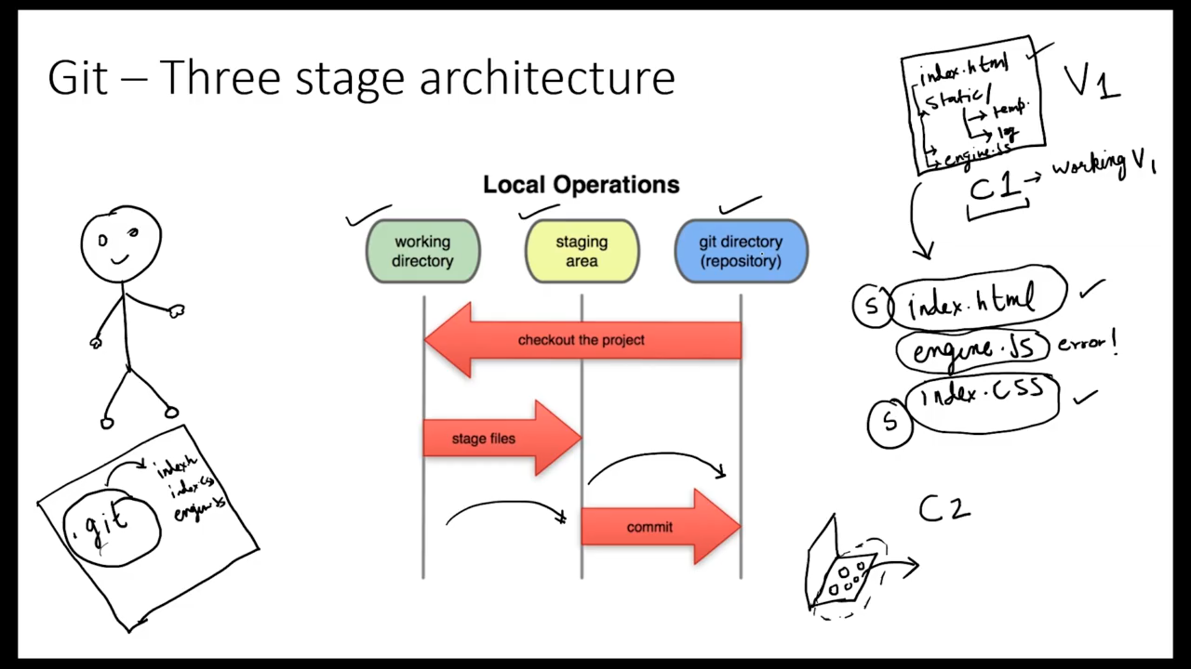

**L4 : Tracking_Our_first_Git_Project :**

git status : to check the status of the git repository.

Spider@DESKTOP-ERP36RG MINGW64 /e/My Study Zone/JS Tech/2019 Github Code with Ha

rry/Git_P

$ git status

fatal: not a git repository (or any of the parent directories): .git

Spider@DESKTOP-ERP36RG MINGW64 /e/My Study Zone/JS Tech/2019 Github Code with Ha

rry/Git_P

$ git init

Initialized empty Git repository in E:/My Study Zone/JS Tech/2019 Github Code wi

th Harry/Git_P/.git/

Spider@DESKTOP-ERP36RG MINGW64 /e/My Study Zone/JS Tech/2019 Github Code with Ha

rry/Git_P (master)

$ git status

On branch master

No commits yet

Untracked files:

(use "git add ..." to include in what will be committed)

db.accdb

first.txt

myexcel.xlsx

second.txt

nothing added to commit but untracked files present (use "git add" to track)

Spider@DESKTOP-ERP36RG MINGW64 /e/My Study Zone/JS Tech/2019 Github Code with Ha

rry/Git_P (master)

$

Phele yeh git status per error de raha tha , per ab humne git init krke isko git repo bana diya hai ab yeh status bhi dega, ab git ki zimedari hai isko track krne ki.

Note : git init se do kam honge ek do wo .git ek hideen file banyege same directory mein 2nd wo master branch bana dega isko.

Note or yeh red color se dikhega agar track kiya hua nahi hai

Ek cheej or bta raha hai ki apne kuch files ko track nahi kiya hai

nothing added to commit but untracked files present (use "git add" to track

iske liye app **git add - –a --a means ALL** likhe : iska matlab hai sari files ko aap staging area mein daal de .(All files)

What is branch ? learn later

AB agar apne track krliya hai meand git add –a toh ab sabhi changes apke staging area mein ajeyge or color green ho jayega unka. Ab yeh track files hai

Spider@DESKTOP-ERP36RG MINGW64 /e/My Study Zone/JS Tech/2019 Github Code with Ha

rry/Git_P (master)

$ git status

On branch master

No commits yet

Untracked files:

(use "git add ..." to include in what will be committed)

db.accdb

first.txt

myexcel.xlsx

second.txt

nothing added to commit but untracked files present (use "git add" to track)

Spider@DESKTOP-ERP36RG MINGW64 /e/My Study Zone/JS Tech/2019 Github Code with Ha

rry/Git_P (master)

$ git add --a

Spider@DESKTOP-ERP36RG MINGW64 /e/My Study Zone/JS Tech/2019 Github Code with Ha

rry/Git_P (master)

$ git status

On branch master

No commits yet

Changes to be committed:

(use "git rm --cached ..." to unstage)

new file: db.accdb

new file: first.txt

new file: myexcel.xlsx

new file: second.txt

Spider@DESKTOP-ERP36RG MINGW64 /e/My Study Zone/JS Tech/2019 Github Code with Ha

rry/Git_P (master)

$

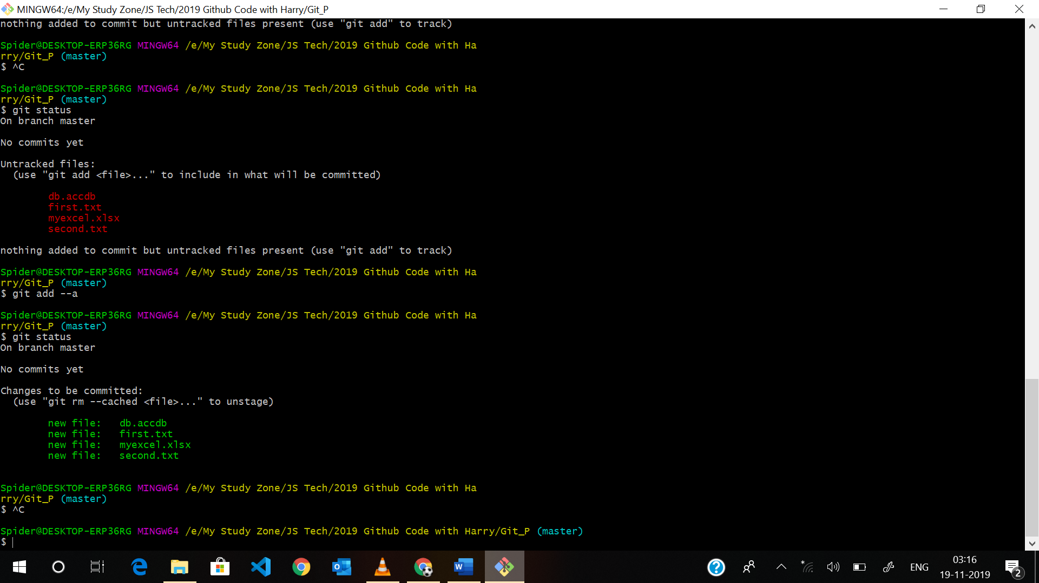

Ab yeh new files hai sari jo staging se repo per jygi toh mein chahta hun ki inka ek snapshot ajye means commit karuga

Spider@DESKTOP-ERP36RG MINGW64 /e/My Study Zone/JS Tech/2019 Github Code with Ha

rry/Git_P (master)

$ git status

On branch master

No commits yet

Untracked files:

(use "git add ..." to include in what will be committed)

db.accdb

first.txt

myexcel.xlsx

second.txt

nothing added to commit but untracked files present (use "git add" to track)

Spider@DESKTOP-ERP36RG MINGW64 /e/My Study Zone/JS Tech/2019 Github Code with Ha

rry/Git_P (master)

$ git add --a

Spider@DESKTOP-ERP36RG MINGW64 /e/My Study Zone/JS Tech/2019 Github Code with Ha

rry/Git_P (master)

$ git status

On branch master

No commits yet

Changes to be committed:

(use "git rm --cached ..." to unstage)

new file: db.accdb

new file: first.txt

new file: myexcel.xlsx

new file: second.txt

Spider@DESKTOP-ERP36RG MINGW64 /e/My Study Zone/JS Tech/2019 Github Code with Ha

rry/Git_P (master)

$ ^C

Spider@DESKTOP-ERP36RG MINGW64 /e/My Study Zone/JS Tech/2019 Github Code with Harry/Git_P (master)

$ git commit -m "this is my first version ok"

[master (root-commit) 5b9f063] this is my first version ok

4 files changed, 2 insertions(+)

create mode 100644 db.accdb

create mode 100644 first.txt

create mode 100644 myexcel.xlsx

create mode 100644 second.txt

ab git status likhuga toh yeh kahega apne jitney files commit kit hi sab staging per snapshot aa chuka hai , sab clean hai apka working tree set hai ek dum.

Apko agar purane commit dekhne hai toh app **git log** ikhege.

Spider@DESKTOP-ERP36RG MINGW64 /e/My Study Zone/JS Tech/2019 Github Code with Harry/Git_P (master)

$ git log

commit 5b9f063c41a76903ddf65afad2eace69d9fc673e (HEAD -> master)

Author: Satty Thakur

Date: Tue Nov 19 03:18:31 2019 +0530

this is my first version ok

Spider@DESKTOP-ERP36RG MINGW64 /e/My Study Zone/JS Tech/2019 Github Code with Harry/Git_P (master)

Apne mene kuch files ko modify krdiya hai

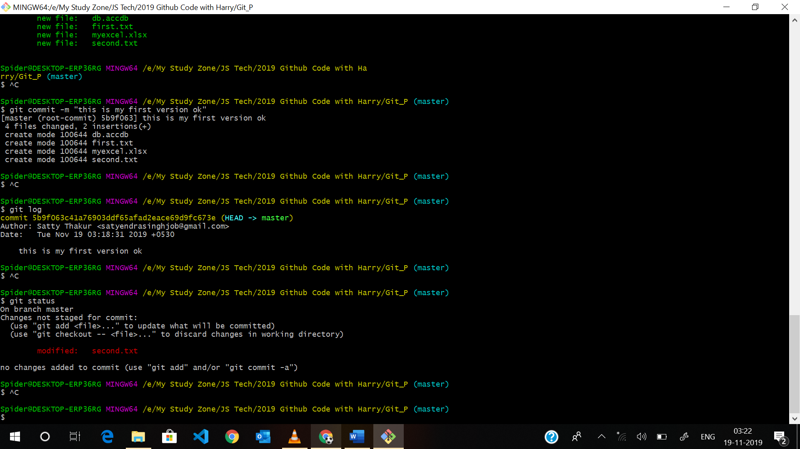



Note : Ab supoose mene do file modify ki or unme se srf ek hi file mein staging area mein dalna chahta hun

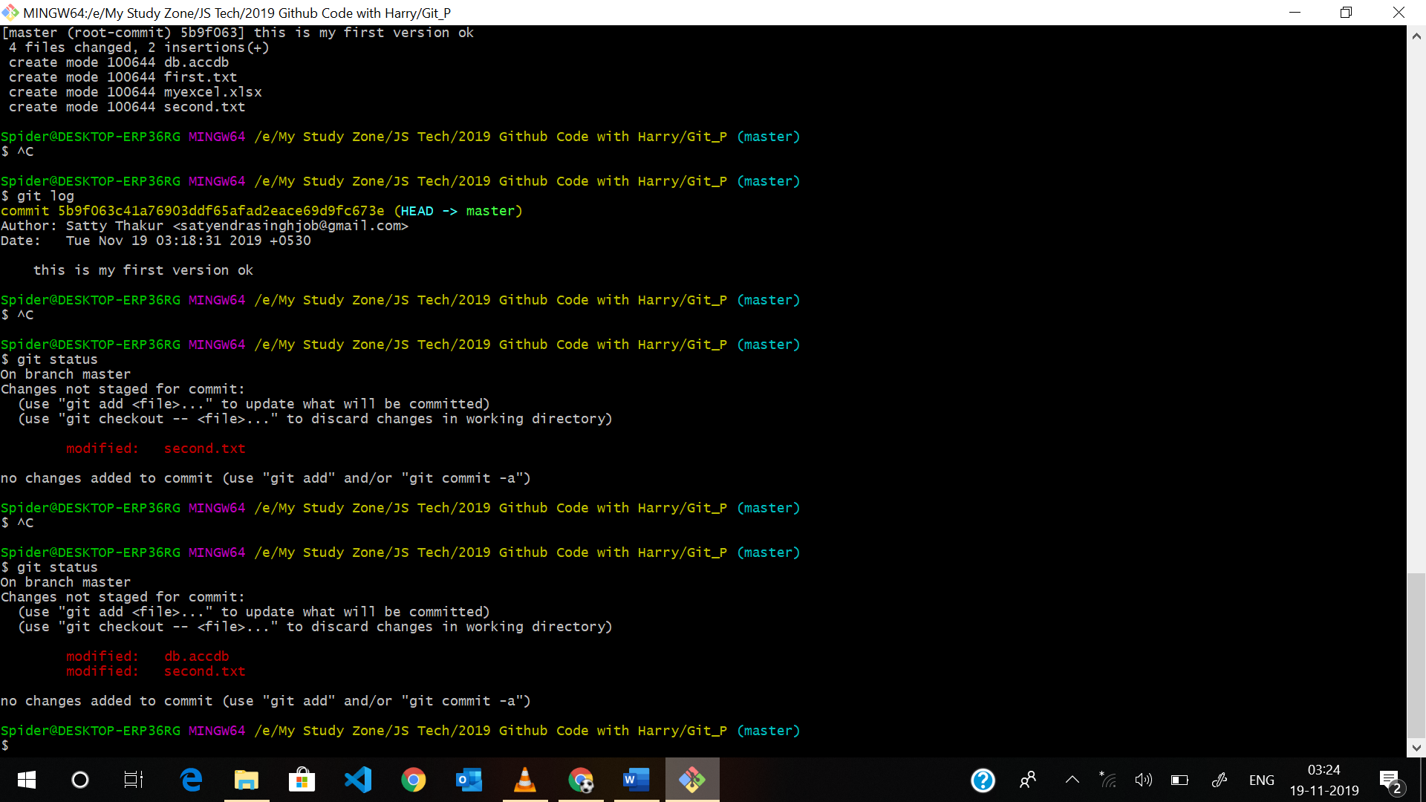

Srf mein second.txt ko commit krna chahta hun db wali ko nahi toh uske liye mein likhuga

Git add second.txt Shift plus INsert

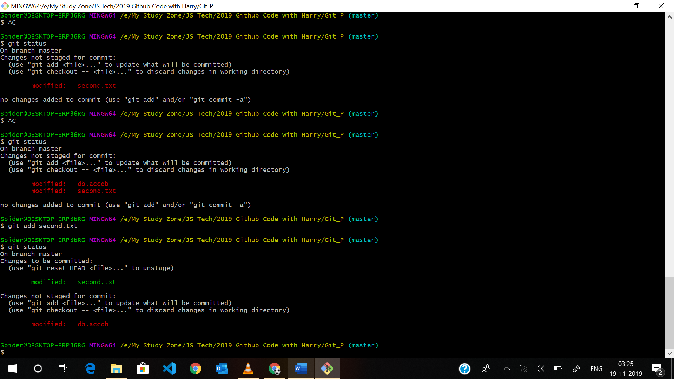

Per abhi apne db wali file ko stage nahi kiya hai



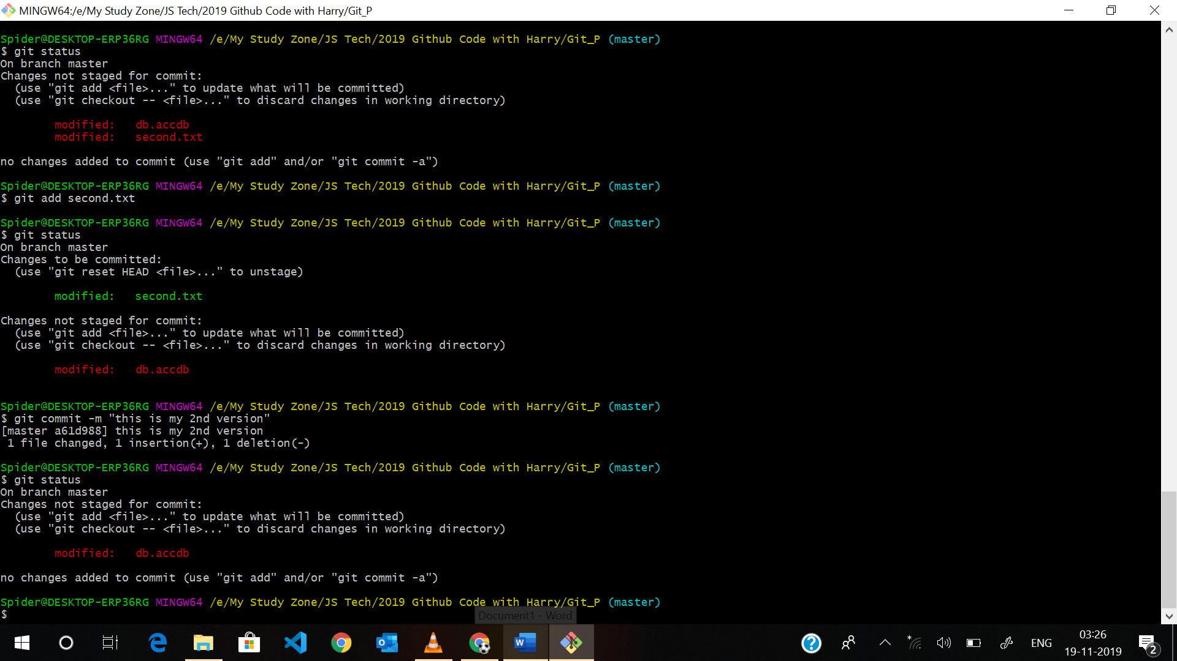

Note : git init kiya dubara toh dubara se re initialize ho jygi ppuri repo.

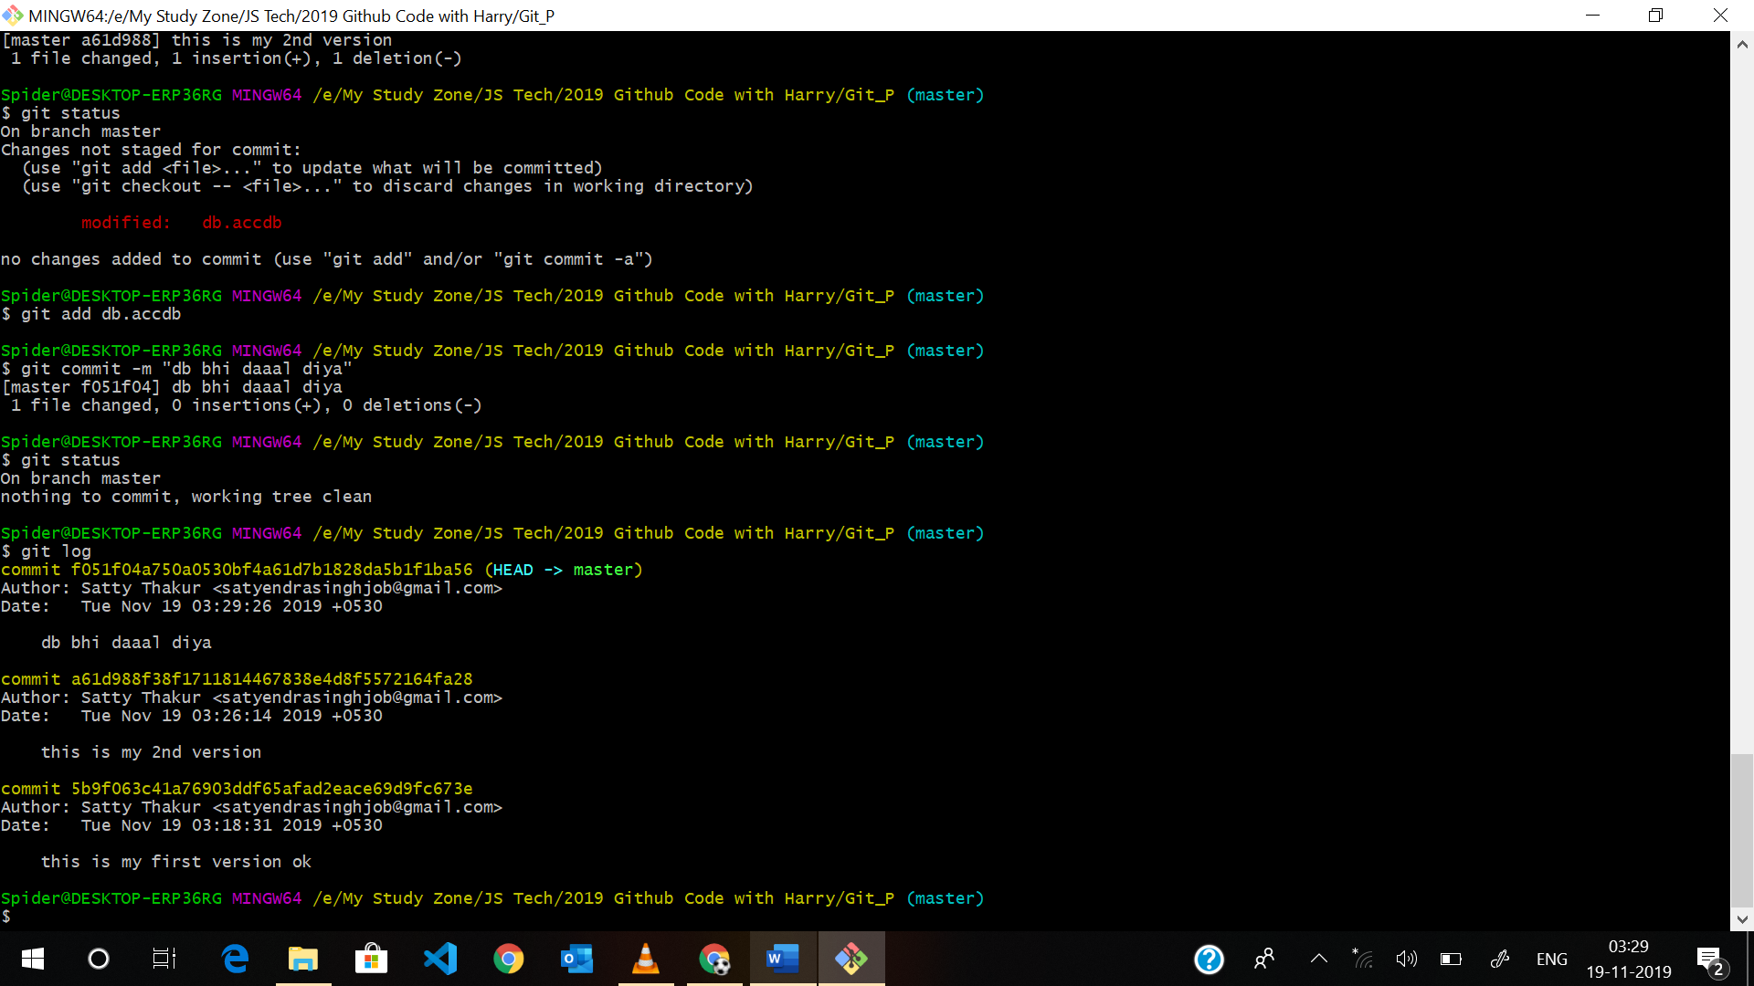

]

Note Agaraap chahte hai kisi ek folder ki git tracking band krna do yeh command chala de but yeh command khatarnak hai .git file bhi delete kr degi yeh]

**rm -rf .git : aap ki ab yeh foler .git delete ho jygi yeh rm -rf linux ki folder remove krne ki command hti hai**

**L5: Cloning_a_Remote_Git_Repository_from_GitHub :**

Spider@DESKTOP-ERP36RG MINGW64 /e/My Study Zone/JS Tech/2019 Github Code with Harry/Git_P (master)

$ git clone https://github.com/github/email_reply_parser.git

Cloning into 'email_reply_parser'...

remote: Enumerating objects: 14, done.

remote: Counting objects: 100% (14/14), done.

remote: Compressing objects: 100% (10/10), done.

remote: Total 515 (delta 3), reused 11 (delta 2), pack-reused 501

Receiving objects: 100% (515/515), 106.77 KiB | 364.00 KiB/s, done.

Resolving deltas: 100% (204/204), done.

Spider@DESKTOP-ERP36RG MINGW64 /e/My Study Zone/JS Tech/2019 Github Code with Harry/Git_P (master)

$

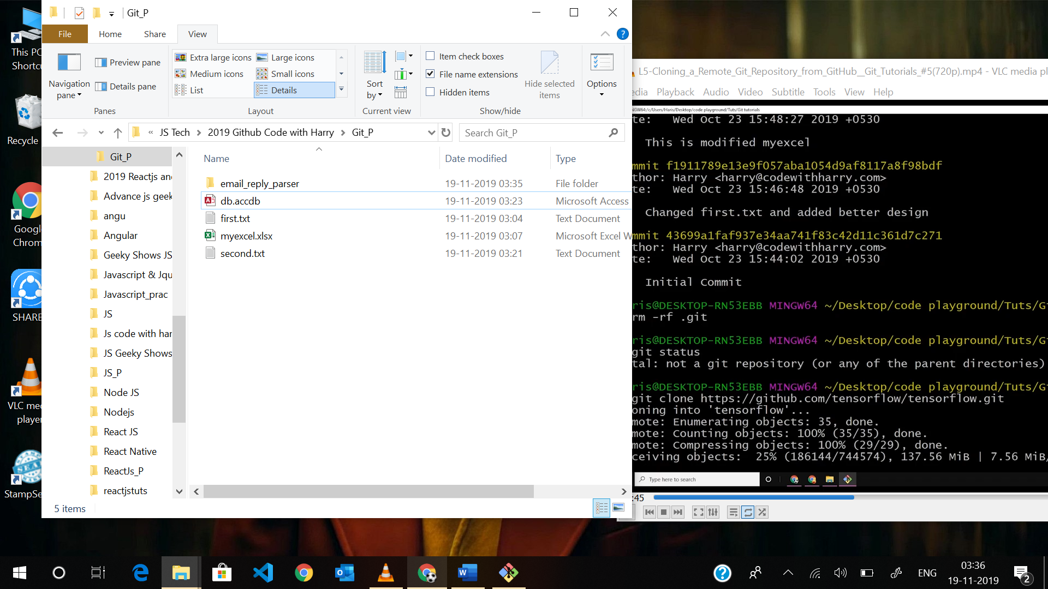

Suppose mujhe sika naam change krna hota clone krte time

Spider@DESKTOP-ERP36RG MINGW64 /e/My Study Zone/JS Tech/2019 Github Code with Harry/Git_P (master)

$ git clone https://github.com/github/email_reply_parser.git myemailfolder

Cloning into 'myemailfolder'...

remote: Enumerating objects: 14, done.

remote: Counting objects: 100% (14/14), done.

remote: Compressing objects: 100% (10/10), done.

remote: Total 515 (delta 3), reused 11 (delta 2), pack-reused 501

Receiving objects: 100% (515/515), 106.77 KiB | 369.00 KiB/s, done.

Resolving deltas: 100% (204/204), done.

Spider@DESKTOP-ERP36RG MINGW64 /e/My Study Zone/JS Tech/2019 Github Code with Harry/Git_P (master)

$

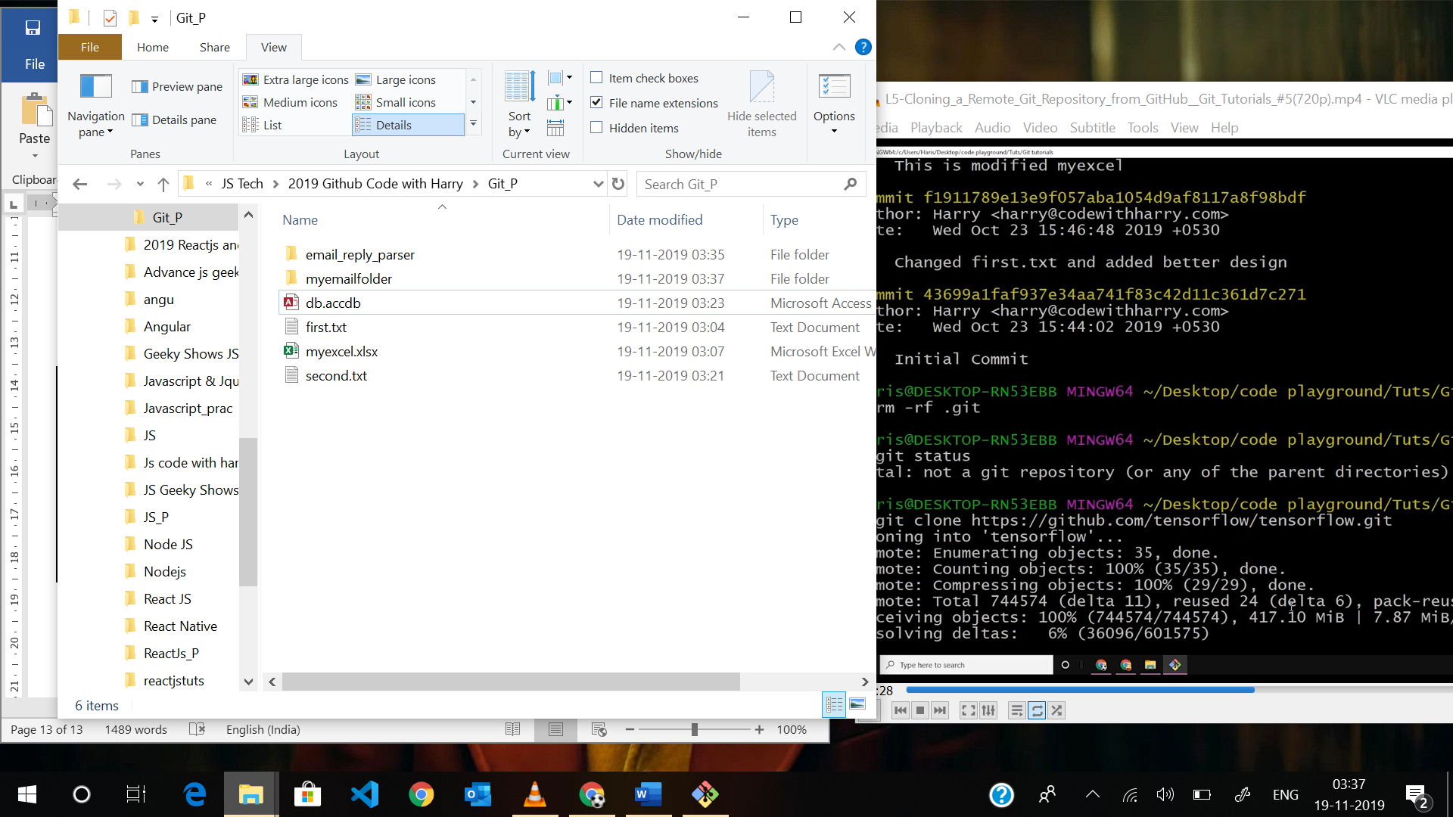

Ise ab yeh sari repo mere local computer mein le ayega.

Linux based command : pwd : present working dir aap ksi directory mein ho, ls : list content : apki kitni file hai us directory mein

Spider@DESKTOP-ERP36RG MINGW64 /e/My Study Zone/JS Tech/2019 Github Code with Harry/Git_P (master)

$ pwd

/e/My Study Zone/JS Tech/2019 Github Code with Harry/Git_P

Spider@DESKTOP-ERP36RG MINGW64 /e/My Study Zone/JS Tech/2019 Github Code with Harry/Git_P (master)

$ ls

db.accdb email_reply_parser/ first.txt myemailfolder/ myexcel.xlsx second.txt

Spider@DESKTOP-ERP36RG MINGW64 /e/My Study Zone/JS Tech/2019 Github Code with Harry/Git_P (master)

$

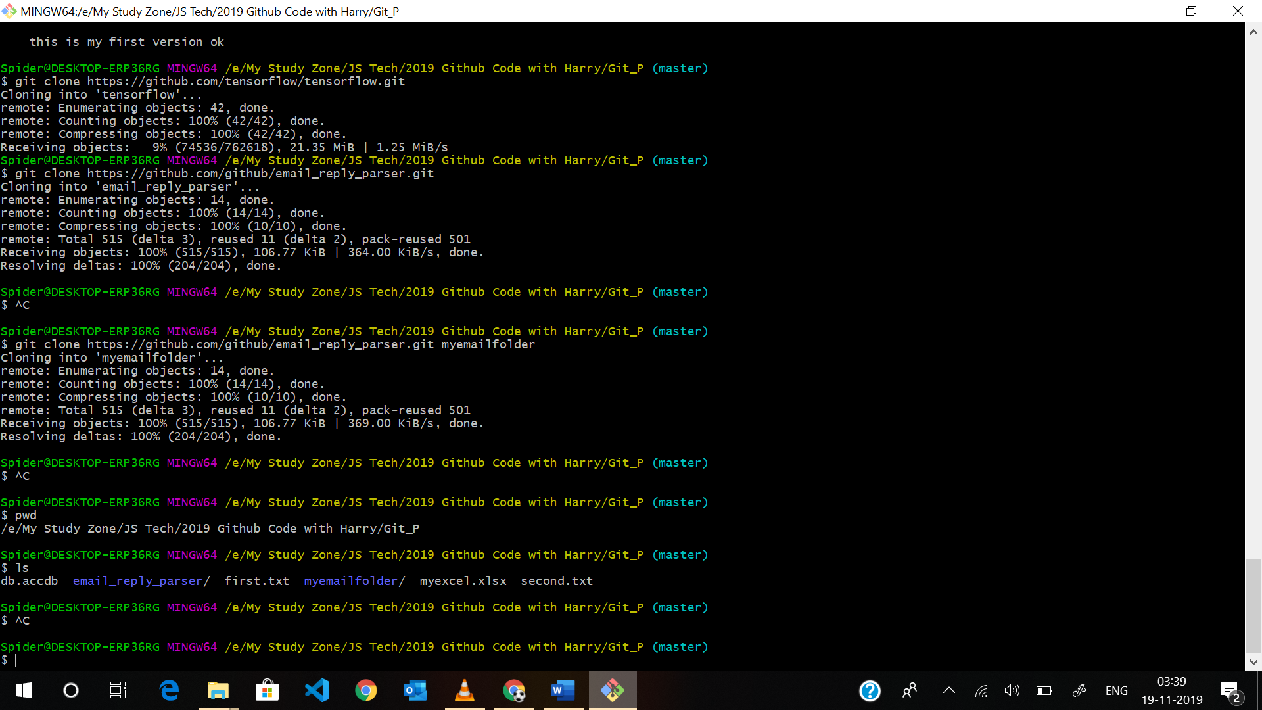

Note : Q se quit hota hai isme.

**L6-_File_Status_Lifecycle**

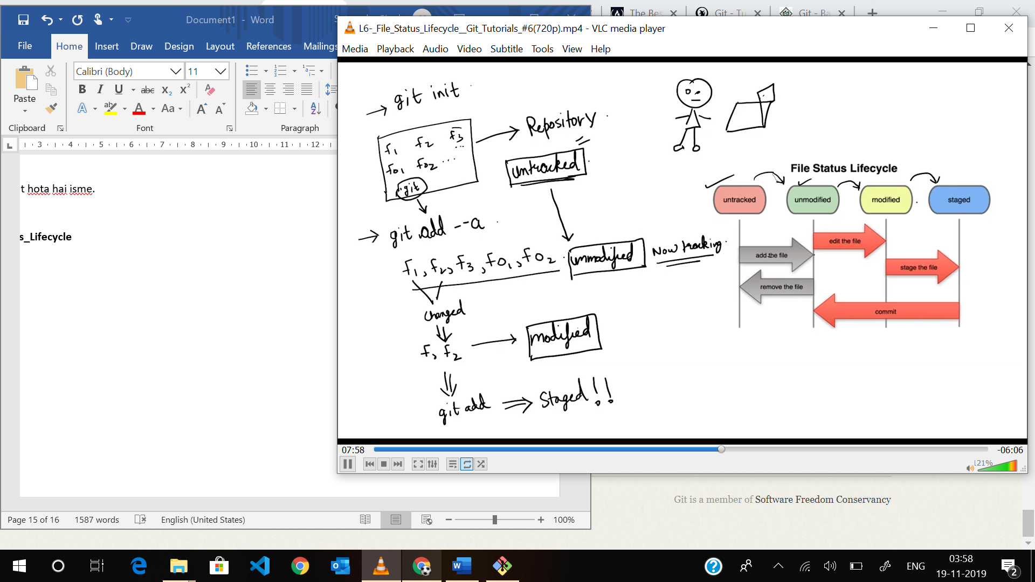

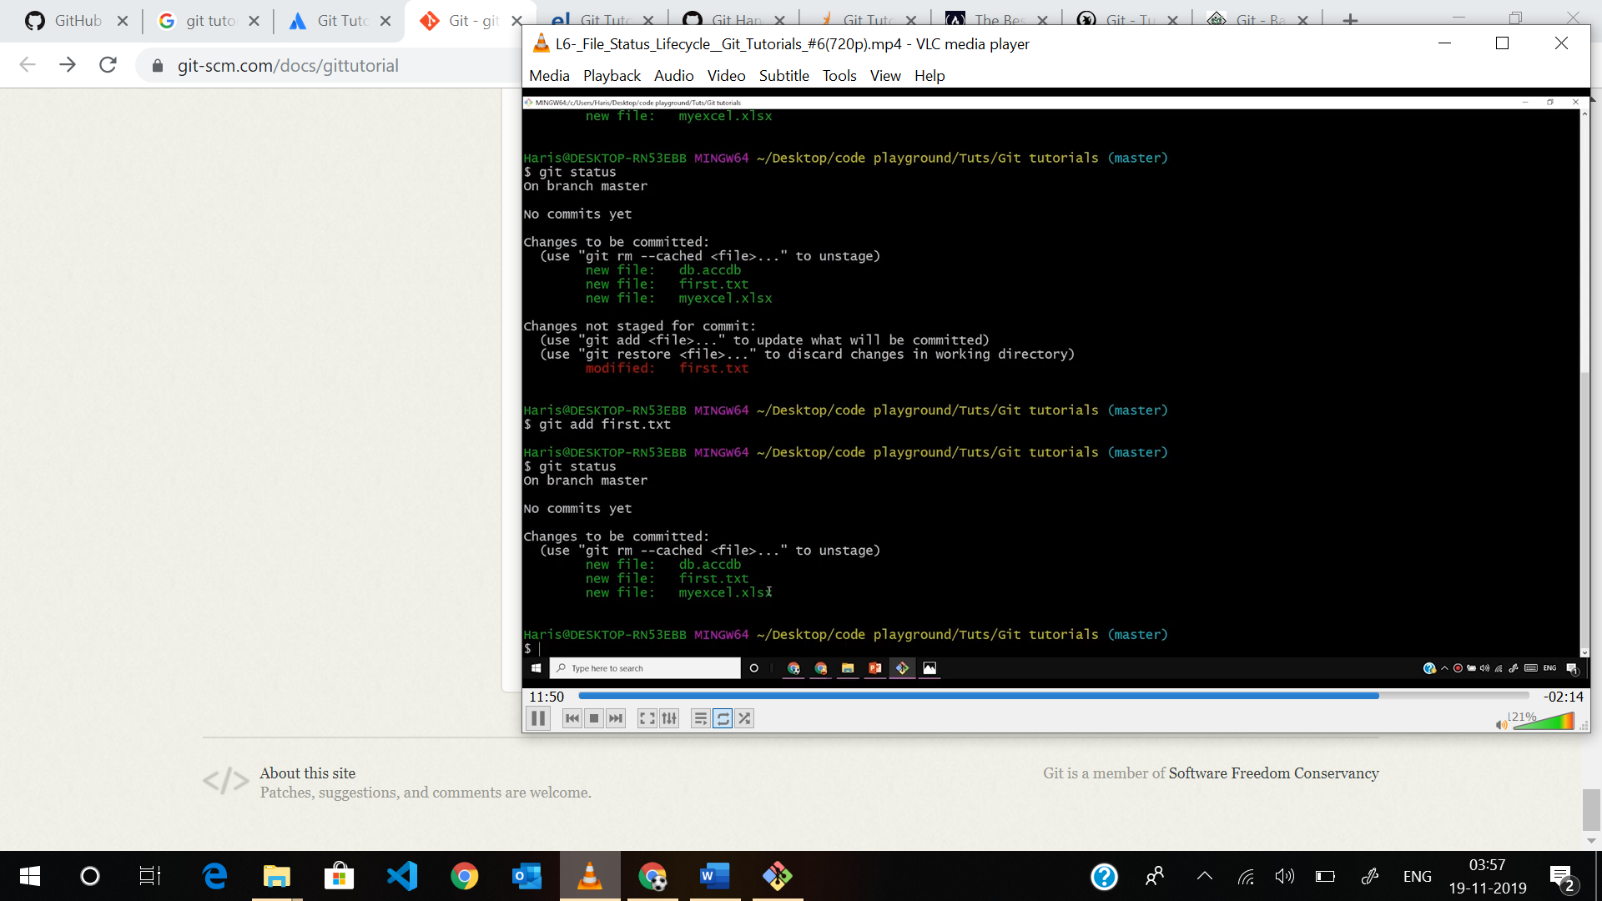

**L7-_Ignoring_Files_in_Git_ :**

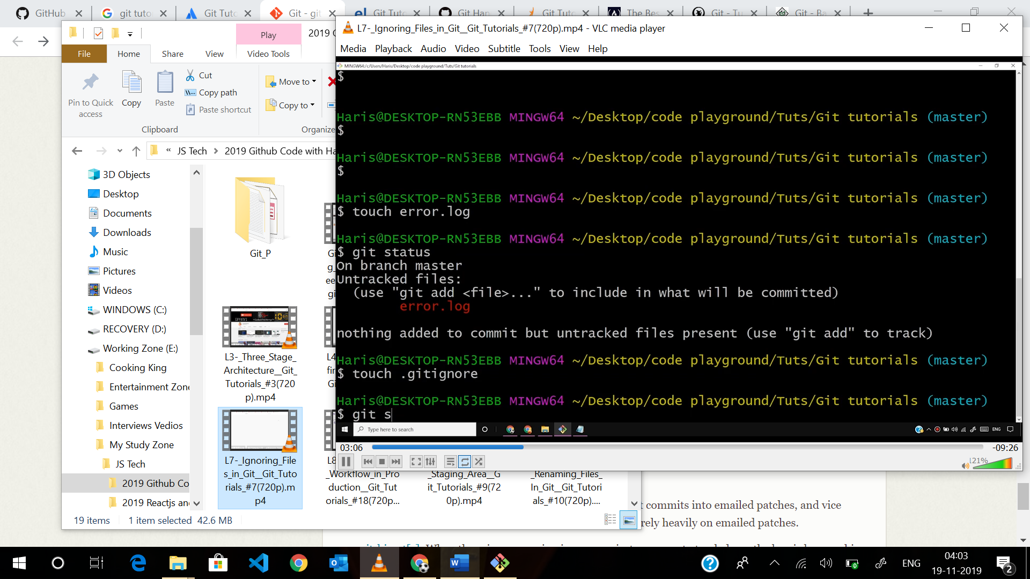

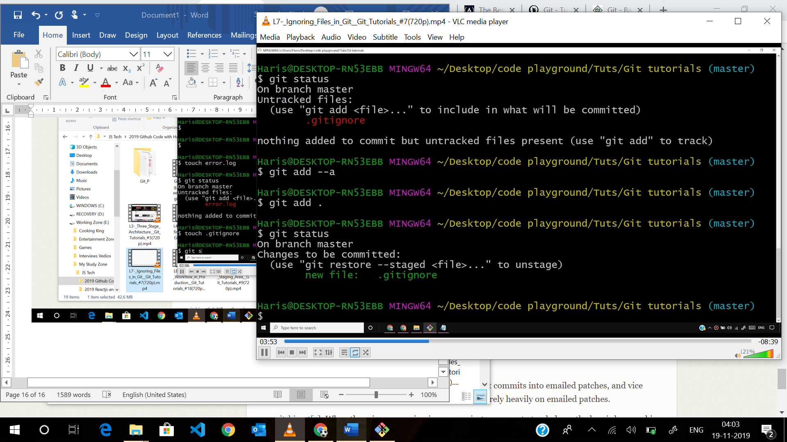

.gitignore file :

Error.log

*log : all log file ignore

Dirigno/ : directory ignore